**Exercise 1: Control Structures**

**Scenario 1:** The bank wants to apply a discount to loan interest rates for customers above 60 years old.

**Question:** Write a PL/SQL block that loops through all customers, checks their age, and if they are above 60, apply a 1% discount to their current loan interest rates.

Answer:

SELECT * FROM CUSTOMERS;

SELECT * FROM LOANS;

SET SERVEROUTPUT ON;

DECLARE

CURSOR CUSTOMER_CURSOR IS

SELECT CUSTOMERID, EXTRACT(YEAR FROM SYSDATE) - EXTRACT(YEAR FROM DOB) AS AGE

FROM CUSTOMERS;

VAR_CUSTOMER_ID CUSTOMERS.CUSTOMERID%TYPE;

VAR_AGE NUMBER;

BEGIN

FOR CUSTOMER_RECORD IN CUSTOMER_CURSOR LOOP

VAR_CUSTOMER_ID := CUSTOMER_RECORD.CUSTOMERID;

VAR_AGE := CUSTOMER_RECORD.AGE;

IF VAR_AGE > 60 THEN

UPDATE LOANS

SET INTERESTRATE = INTERESTRATE - 1

WHERE CUSTOMERID = VAR_CUSTOMER_ID;

ELSE

DBMS_OUTPUT.PUT_LINE('CUSTOMER WITH CUSTOMER ID : ' || VAR_CUSTOMER_ID || ' IS OF AGE : ' || VAR_AGE);

DBMS_OUTPUT.PUT_LINE('NO CHANGE IN LOAN');

END IF;

END LOOP;

COMMIT;

END;

/

SELECT * FROM LOANS;

**Output:**

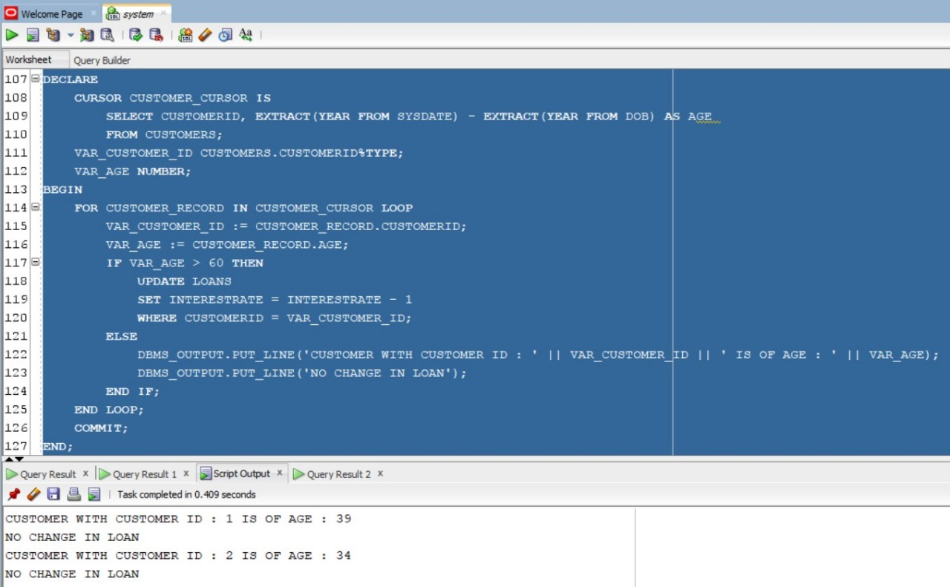

**Scenario 2:** A customer can be promoted to VIP status based on their balance.

**Question:** Write a PL/SQL block that iterates through all customers and sets a flag IsVIP to TRUE for those with a balance over $10,000.

**Answer:**

DESC CUSTOMERS;

ALTER TABLE CUSTOMERS ADD ISVIP CHAR(10) CONSTRAINT CHK1 CHECK(ISVIP IN ('TRUE','FALSE')) ;

SELECT * FROM CUSTOMERS;

SET SERVEROUTPUT ON;

DECLARE

CURSOR CUSTOMER_CURSOR IS

SELECT CUSTOMERID, BALANCE

FROM CUSTOMERS;

VAR_CUSTOMER_ID CUSTOMERS.CUSTOMERID%TYPE;

VAR_BALANCE CUSTOMERS.BALANCE%TYPE;

BEGIN

FOR CUSTOMER_RECORD IN CUSTOMER_CURSOR LOOP

VAR_CUSTOMER_ID := CUSTOMER_RECORD.CUSTOMERID;

VAR_BALANCE := CUSTOMER_RECORD.BALANCE;

IF VAR_BALANCE > 10000 THEN

DBMS_OUTPUT.PUT_LINE('CUSTOMER ID : ' || VAR_CUSTOMER_ID || ' HAS BALANCE GREATER THAN 10000');

UPDATE CUSTOMERS

SET ISVIP = 'TRUE'

WHERE CUSTOMERID = VAR_CUSTOMER_ID;

ELSE

DBMS_OUTPUT.PUT_LINE('CUSTOMER ID : ' || VAR_CUSTOMER_ID || ' HAS BALANCE LESSER THAN 10000');

UPDATE CUSTOMERS

SET ISVIP = 'FALSE'

WHERE CUSTOMERID = VAR_CUSTOMER_ID;

END IF;

END LOOP;

COMMIT;

END;

/

SELECT * FROM CUSTOMERS;

**Output:**

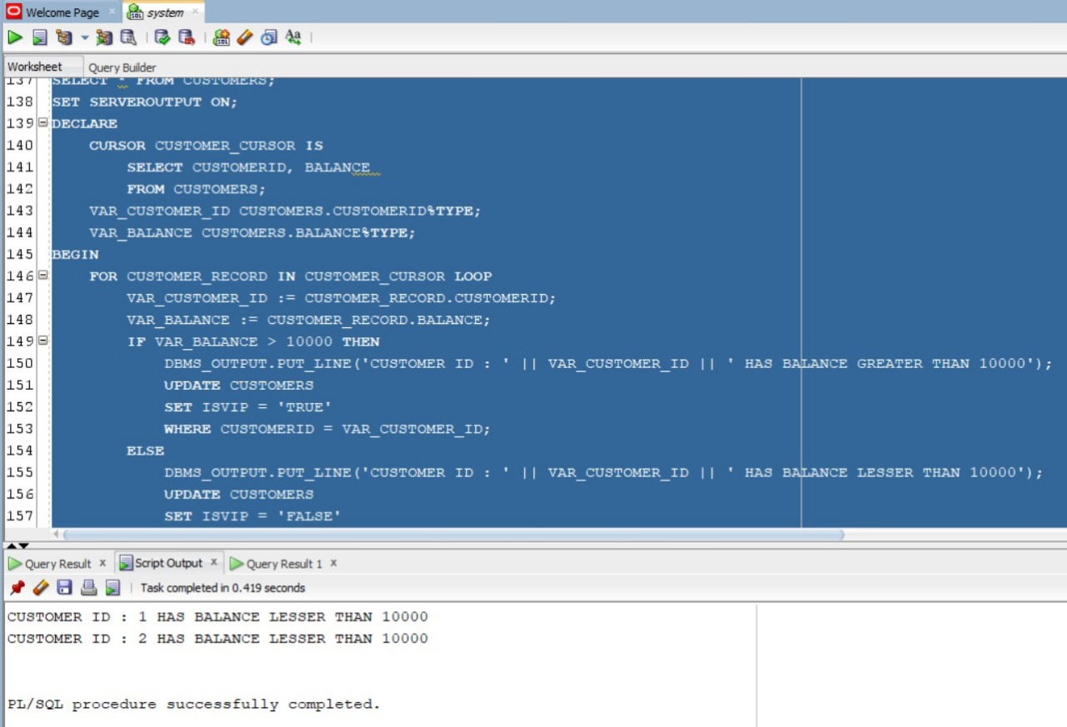

**Scenario 3:** The bank wants to send reminders to customers whose loans are due within the next 30 days.

**Question:** Write a PL/SQL block that fetches all loans due in the next 30 days and prints a reminder message for each customer.

**Answer:**

SET SERVEROUTPUT ON;

DECLARE

CURSOR CUR_LOANS IS

SELECT L.LOANID, L.CUSTOMERID, C.NAME, L.ENDDATE

FROM LOANS L

JOIN CUSTOMERS C ON L.CUSTOMERID = C.CUSTOMERID

WHERE L.ENDDATE BETWEEN SYSDATE AND SYSDATE + 30;

V_LOAN_ID LOANS.LOANID%TYPE;

V_CUSTOMER_ID LOANS.CUSTOMERID%TYPE;

V_CUSTOMER_NAME CUSTOMERS.NAME%TYPE;

V_END_DATE LOANS.ENDDATE%TYPE;

V_FOUND BOOLEAN := FALSE;

BEGIN

OPEN CUR_LOANS;

LOOP

FETCH CUR_LOANS INTO V_LOAN_ID, V_CUSTOMER_ID, V_CUSTOMER_NAME, V_END_DATE;

EXIT WHEN CUR_LOANS%NOTFOUND;

V_FOUND := TRUE;

DBMS_OUTPUT.PUT_LINE('Reminder: Loan ' || V_LOAN_ID || ' for customer ' || V_CUSTOMER_NAME || ' (ID: ' || V_CUSTOMER_ID || ') is due on ' || TO_CHAR(V_END_DATE, 'YYYY-MM-DD'));

END LOOP;

CLOSE CUR_LOANS;

IF NOT V_FOUND THEN

DBMS_OUTPUT.PUT_LINE('No loans are due within the next 30 days.');

END IF;

END;

/

**Output:**

**Schema to be Created:**

CREATE TABLE CUSTOMERS (

CUSTOMERID NUMBER PRIMARY KEY,

NAME VARCHAR2(100),

DOB DATE,

BALANCE NUMBER,

LASTMODIFIED DATE

);

CREATE TABLE ACCOUNTS (

ACCOUNTID NUMBER PRIMARY KEY,

CUSTOMERID NUMBER,

ACCOUNTTYPE VARCHAR2(20),

BALANCE NUMBER,

LASTMODIFIED DATE,

FOREIGN KEY ( CUSTOMERID )

REFERENCES CUSTOMERS ( CUSTOMERID )

);

CREATE TABLE TRANSACTIONS (

TRANSACTIONID NUMBER PRIMARY KEY,

ACCOUNTID NUMBER,

TRANSACTIONDATE DATE,

AMOUNT NUMBER,

TRANSACTIONTYPE VARCHAR2(10),

FOREIGN KEY ( ACCOUNTID )

REFERENCES ACCOUNTS ( ACCOUNTID )

);

CREATE TABLE LOANS (

LOANID NUMBER PRIMARY KEY,

CUSTOMERID NUMBER,

LOANAMOUNT NUMBER,

INTERESTRATE NUMBER,

STARTDATE DATE,

ENDDATE DATE,

FOREIGN KEY ( CUSTOMERID )

REFERENCES CUSTOMERS ( CUSTOMERID )

);

CREATE TABLE EMPLOYEES (

EMPLOYEEID NUMBER PRIMARY KEY,

NAME VARCHAR2(100),

POSITION VARCHAR2(50),

SALARY NUMBER,

DEPARTMENT VARCHAR2(50),

HIREDATE DATE

);

-- INSERT INTO CUSTOMERS

INSERT INTO CUSTOMERS (CUSTOMERID, NAME, DOB, BALANCE, LASTMODIFIED)

VALUES (1, 'John Doe', TO_DATE('1985-05-15', 'YYYY-MM-DD'), 1000, SYSDATE);

INSERT INTO CUSTOMERS (CUSTOMERID, NAME, DOB, BALANCE, LASTMODIFIED)

VALUES (2, 'Jane Smith', TO_DATE('1990-07-20', 'YYYY-MM-DD'), 1500, SYSDATE);

-- INSERT INTO ACCOUNTS

INSERT INTO ACCOUNTS (ACCOUNTID, CUSTOMERID, ACCOUNTTYPE, BALANCE, LASTMODIFIED)

VALUES (1, 1, 'Savings', 1000, SYSDATE);

INSERT INTO ACCOUNTS (ACCOUNTID, CUSTOMERID, ACCOUNTTYPE, BALANCE, LASTMODIFIED)

VALUES (2, 2, 'Checking', 1500, SYSDATE);

-- INSTER INTO TRANSACTIONS

INSERT INTO TRANSACTIONS (TRANSACTIONID, ACCOUNTID, TRANSACTIONDATE, AMOUNT, TRANSACTIONTYPE)

VALUES (1, 1, SYSDATE, 200, 'Deposit');

INSERT INTO TRANSACTIONS (TRANSACTIONID, ACCOUNTID, TRANSACTIONDATE, AMOUNT, TRANSACTIONTYPE)

VALUES (2, 2, SYSDATE, 300, 'Withdrawal');

-- INSERT INTO LOANS

INSERT INTO LOANS (LOANID, CUSTOMERID, LOANAMOUNT, INTERESTRATE, STARTDATE, ENDDATE)

VALUES (1, 1, 5000, 5, SYSDATE, ADD_MONTHS(SYSDATE, 60));

-- INSERT INTO EMPLOYEES

INSERT INTO EMPLOYEES (EMPLOYEEID, NAME, POSITION, SALARY, DEPARTMENT, HIREDATE)

VALUES (1, 'Alice Johnson', 'Manager', 70000, 'HR', TO_DATE('2015-06-15', 'YYYY-MM-DD'));

INSERT INTO EMPLOYEES (EMPLOYEEID, NAME, POSITION, SALARY, DEPARTMENT, HIREDATE)

VALUES (2, 'Bob Brown', 'Developer', 60000, 'IT', TO_DATE('2017-03-20', 'YYYY-MM-DD'));